Name: __________________________________ #: _______ Date: ____________
Cereal Box Book Report
Due Date: _________________

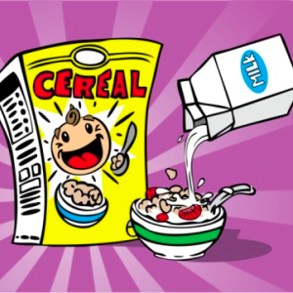

Task: Students will decorate a real cereal box with illustration and information related to the leveled book they read using the directions below. A copy of the rubric is included so that students may check their work against the rubric at any time.

Front of Box: Cover the front of the cereal box (construction paper may work best) to create the front. You need to include the name of the cereal, what kind of cereal it is, a picture of the cereal, and a character to go along with the cereal. Invent a name for the cereal that is related to the title of the book and sounds like a cereal. Do NOT use the exact title of the book. You may want to look at the attached page of real cereal boxes to get some ideas.
Example – For Harry Potter and the Sorcerer’s Stone, you might invent a cereal called Wizard Wands, a toasted oat cereal in the shape of miniature lightning bolts.

Back of Box: Design a game that is based on the book. It can be a puzzle, a word search, a word scramble, a maze, a crossword puzzle, a hidden pictures illustration, or any other fun activity that might be found on the back of a cereal box. Make sure that you have clear directions! Indicate that the reader can find an answer key on the bottom of the box. Also make sure that it includes information from the book.

Bottom of Box: Create an answer key for the game that you included on the back of the box.

Right Side of Box: Write a 5 – 8 sentence summary that describes what the book is about. (Do NOT take this from the blurb on the back of the book!) Try to use words that will hook your reader and make them want to buy your cereal. You can use the attached template (which is also located on my website), or you can create your own.

Left Side of Box: Make a list of “ingredients” that includes the characters and setting. Under the heading “Ingredients,” list the 3 most important characters and write at least one sentence describing each character. Below that, describe the main setting in 2 – 3 sentences. Be descriptive!

Top of Box: Include the title, author, number of pages in the book, and the number of stars you would give this book if you were a book critic. MAKE SURE TO INCLUDE YOUR NAME! You can use the attached template (which is also located on my website), or you can create your own.

Prize in the Box: Cereal boxes often include a prize. Your prize must be something related to the book. This prize should be an important item in the book, something special to one of the main characters, or any other item specific and special to the book. You can even include a picture of the prize on the front of your box to let the reader know what is inside the box.

Things to Note:
*All templates for this cereal box book report will be available to download from the class website (mrsvargas5.weebly.com).
*If students need to borrow supplies because they are not available at home, please contact me.
*The cereal boxes are meant to be fun and colorful!

